**STREAMLINING TICKET ASSIGNMENT FOR EFFICIENT SUPPORT OPERATIONS**

**Team ID:** NM2025TMID19796

**Team Members: 4**

**Team Leader:**  KANNAN V

**Team Member 1:**  SAI KUMAR E

**Team Member 2:**  SANAULLA C M

**Team Member 3:**  SACHIN K

*Problem Definition:*

The objective of this initiative is to implement an automated system for ticket routing at ABC Corporation, aimed at improving operational efficiency by accurately assigning support tickets to the appropriate teams. This solution aims to reduce delays in issue resolution, enhance customer satisfaction, and optimize resource utilization within the support department.

*Objectives:*

**1. Define User Roles Clearly**

* To create and assign appropriate users, groups, and roles in ServiceNow, ensuring that responsibilities are well defined.
* To establish role-based access control (RBAC) by configuring ACLs, so that only authorized members can access or modify specific data.
* To enhance security and accountability by mapping each support function to its corresponding role.
* **2. Mechanism of Automated Ticketing System:**
* To design a structured ticket routing process where issues are categorized (e.g., login errors, certificate problems, user expiry) and directed to the correct group.
* To eliminate manual intervention in ticket assignment by implementing automated flows in ServiceNow.
* To ensure tickets are consistently and accurately assigned to the right support teams, reducing delays in resolution.

**3. Streamline Workflow Processes**

* To develop a standardized workflow in ServiceNow that integrates ticket creation, assignment, and resolution.
* To improve operational efficiency by reducing time spent on manual ticket handling.
* To optimize resource utilization by ensuring issues are handled by the right teams with minimal effort.
* To support scalability by creating workflows that can be extended to future issue categories or departments.

**Skills:** Users, Groups, Roles, Tables, Access Control List(ACL), Flow Designer.

**TASK INITIATION**

**Milestone 1: Users**

Activity 1: Create Users

* Open service now.
* Click on All  >> search for users
* Select Users under system security
* Click on new
* Fill the following details of Manne Niranjan
* Click on submit

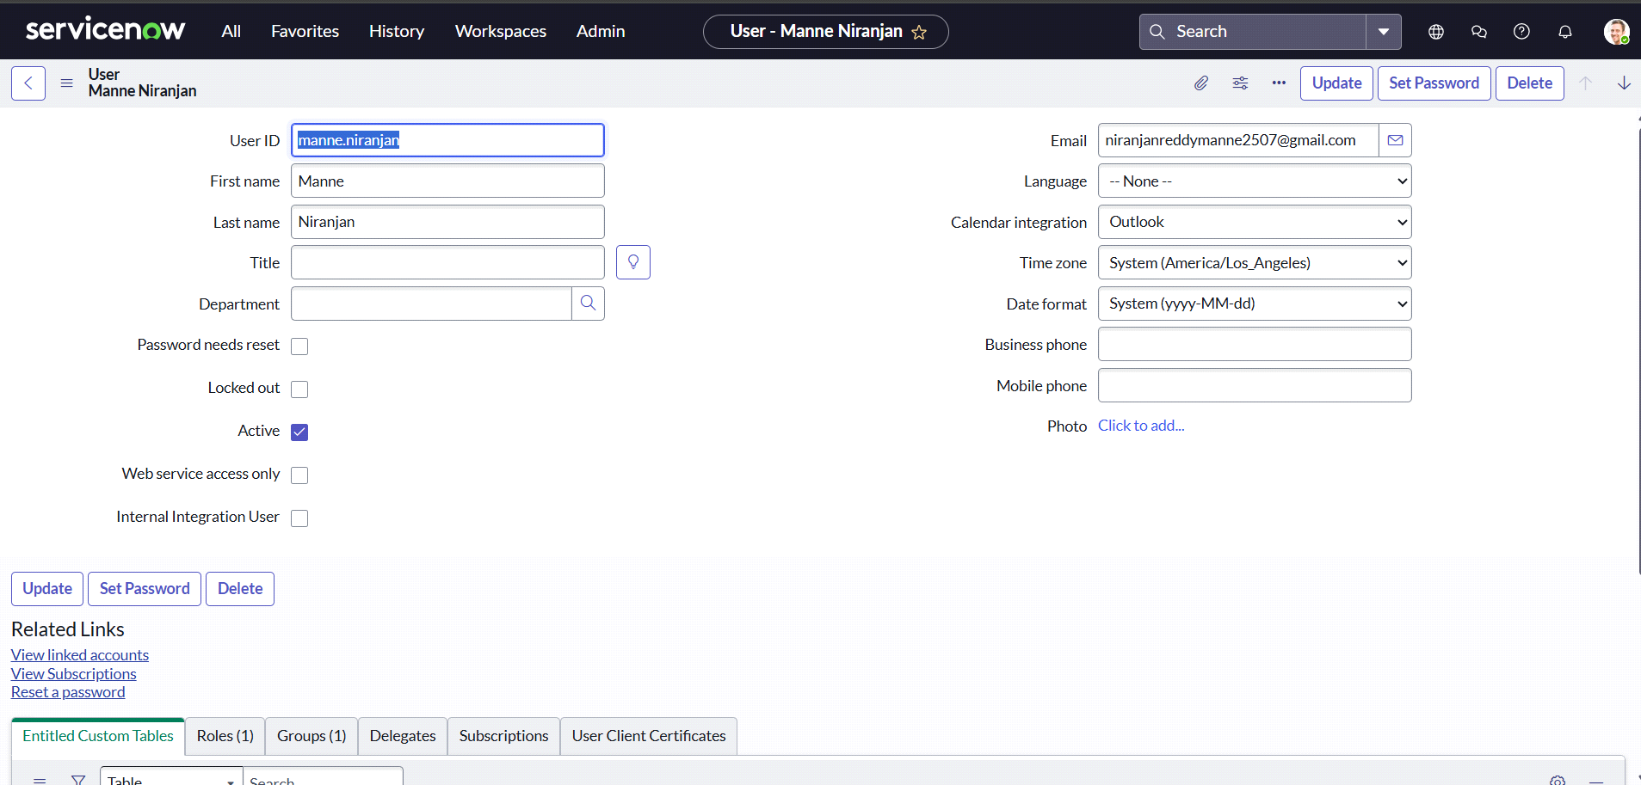

Create one more user:

* Create another user Katherine Pierce with following details.
* Click on submit.

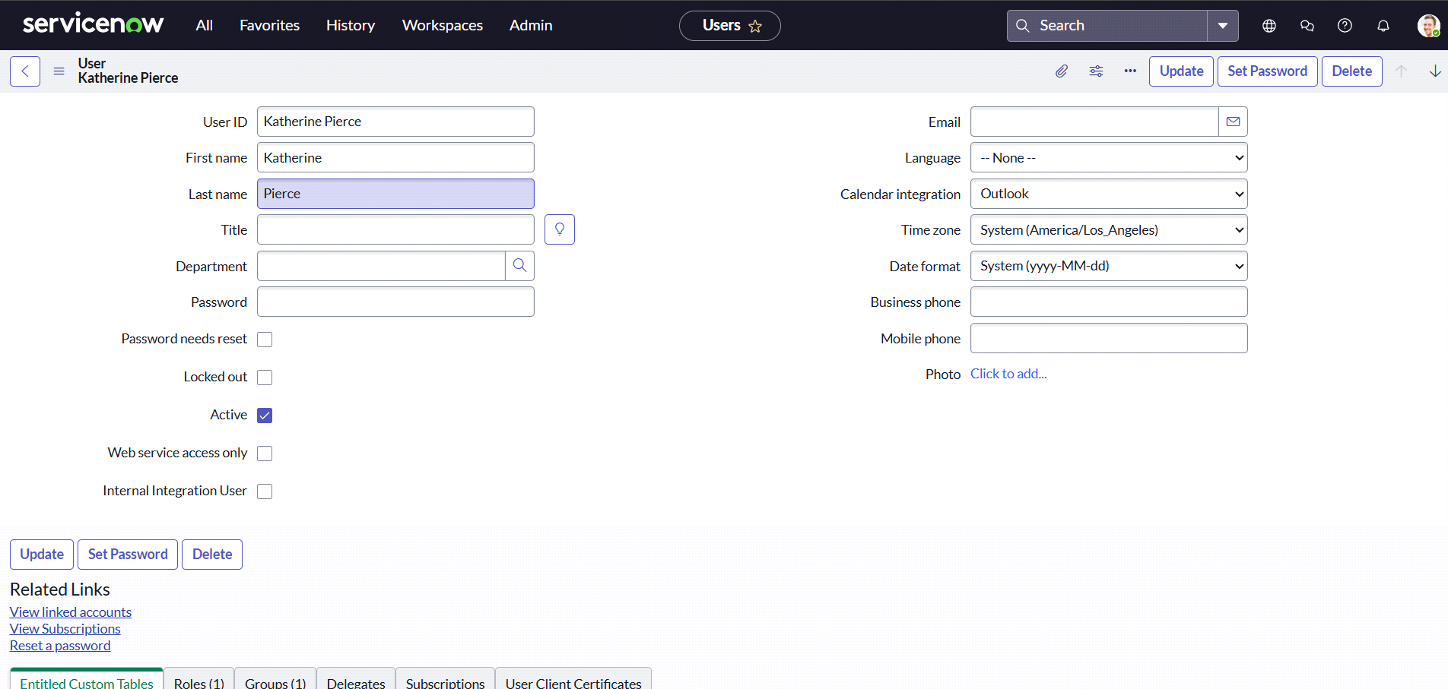

Milestone 2: Groups

Activity 1: Create Groups

* Open service now.
* Click on All  >> search for groups
* Select groups under system security
* Click on new
* Create a new group “certificates” with manager “Katherine Pierce”

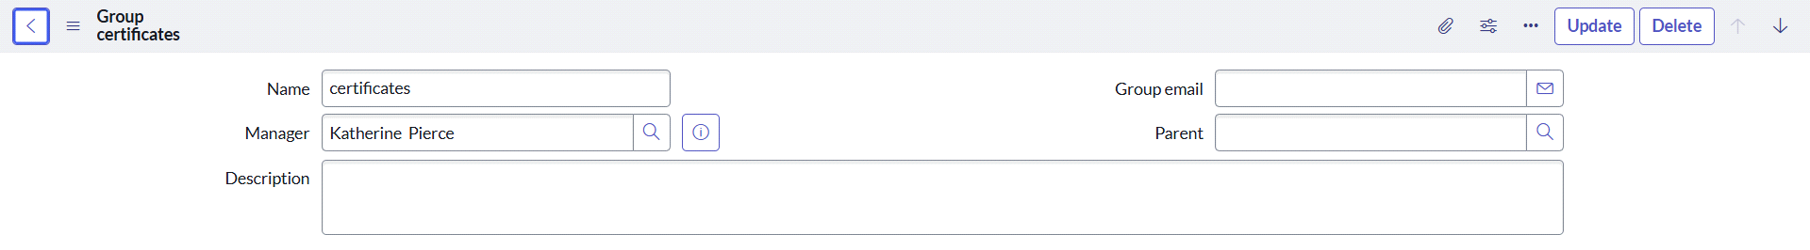

* Create one more group “platform” with manager "Manne Niranjan”

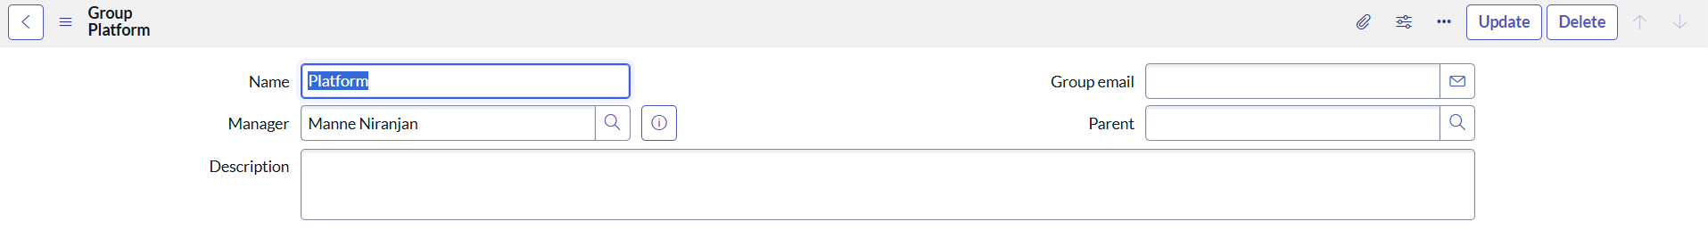

* Click on Submit.

Milestone 3: Roles

Activity 1: Create roles

* Open service now.
* Click on All  >> search for roles
* Select roles under system security
* Click on new
* Create a new role “Certification_role”

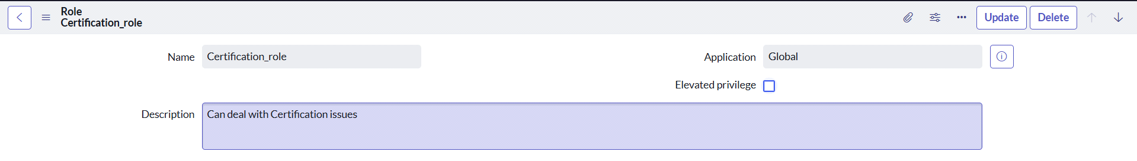

* Click on Submit
* Create a new role “Platform_role”

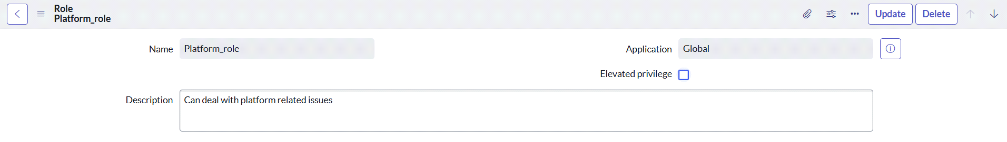

* Click on submit.

Milestone 4: Table

Activity 1: Create Table

* Open service now.
* Click on All  >> search for tables
* Select tables under system definition
* Click on new
* Fill the following details to create a new table  
  Label : Operations related  
  Check the boxes Create module & Create mobile module
* Under new menu name : Operations related
* Under table columns give the columns

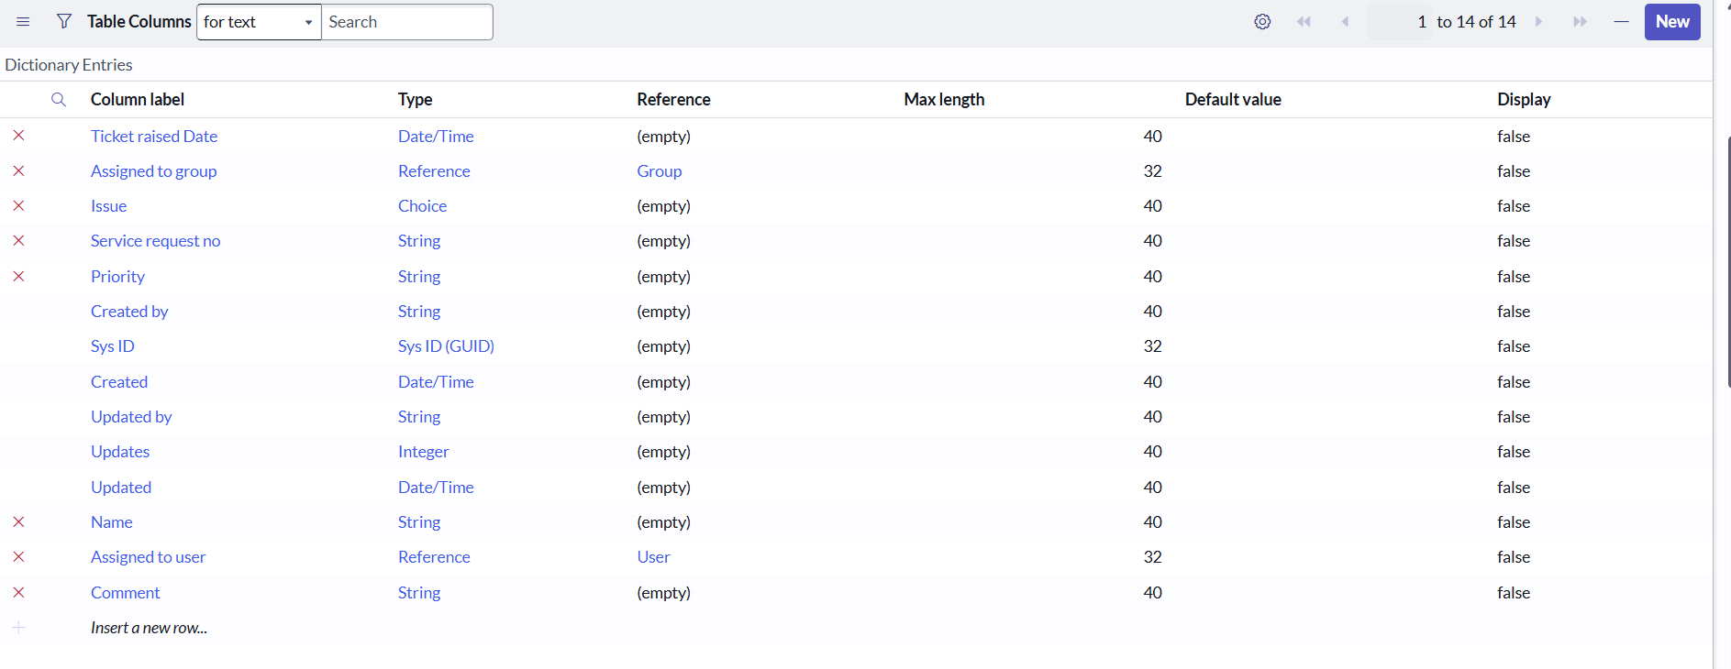

* Click on submit

Create choices for the issue filed by using form design

* unable to login to platform
* 404 error
* regarding certificates
* regarding user expired

Milestone 5: Assign roles & users to groups

Activity 1: Assign roles & users to certificate group

* Open service now.
* Click on All  >> search for groups
* Select groups under system definition
* Select the certificates group
* Under group members
* Click on edit
* Select Katherine Pierce and save
* Click on roles
* Select “Certification_role” and save

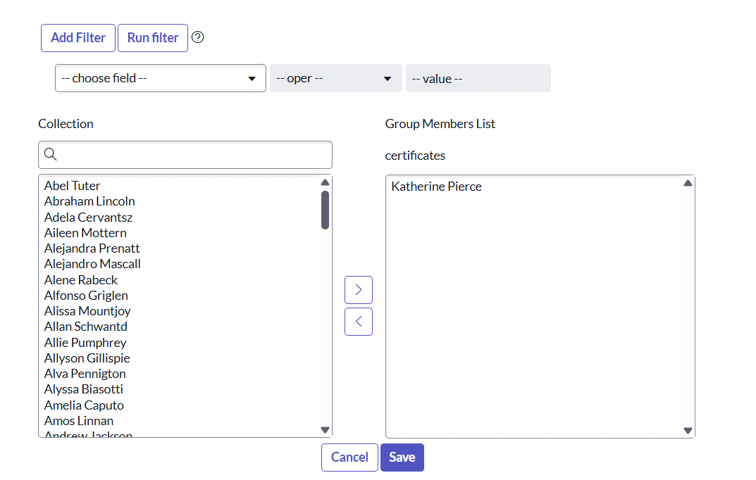

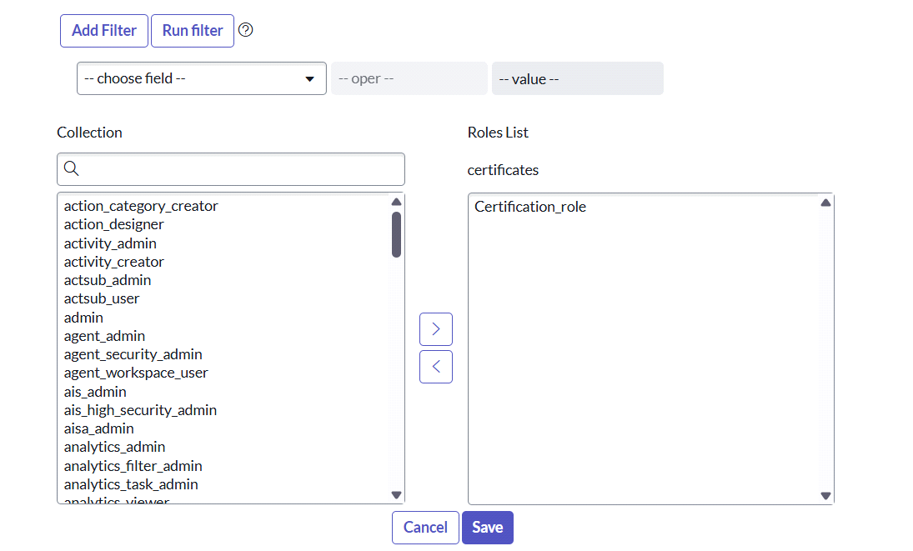

Activity 2: Assign roles & users to platform group

* Open service now.
* Click on All  >> search for groups
* Select groups under system definition
* Select the platform group
* Under group members
* Click on edit
* Select Manne Niranjan and save
* Click on roles
* Select Platform_role and save

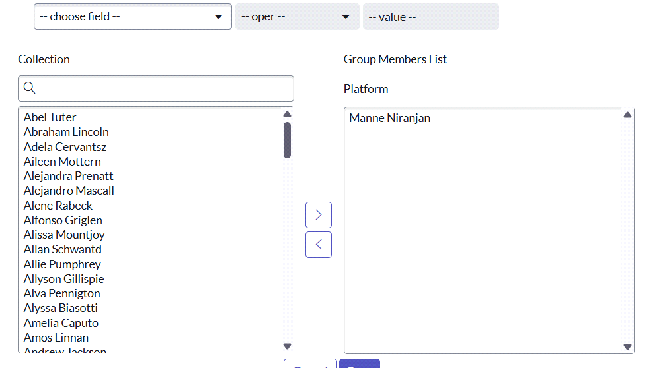

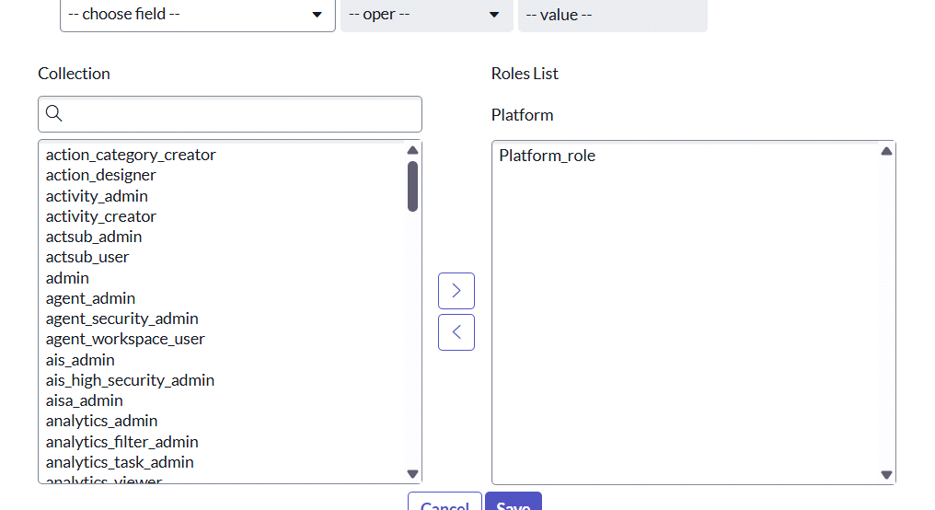

Milestone 6: Assign role to table

Activity 1: Assign role to table

* Open service now.
* Click on All  >> search for tables
* Select operations related table
* Click on the Application Access
* Click on u_operations_related read operation
* Click on the profile on top right side
* Click on elevate role
* Click on security admin and click on update

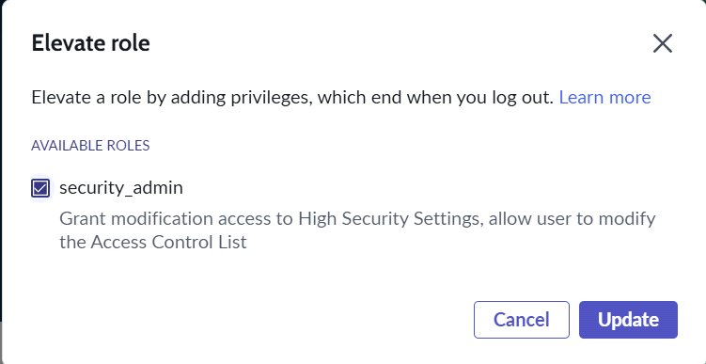

* Under Requires role
* Double click on insert a new row
* Give platform role
* And add certificate role
* Click on update

Milestone 7: Create ACL

Activity 2: create ACL

* Open service now.
* Click on All  >> search for ACL
* Select Access Control(ACL) under system security
* Click on new
* Fill the following details to create a new ACL

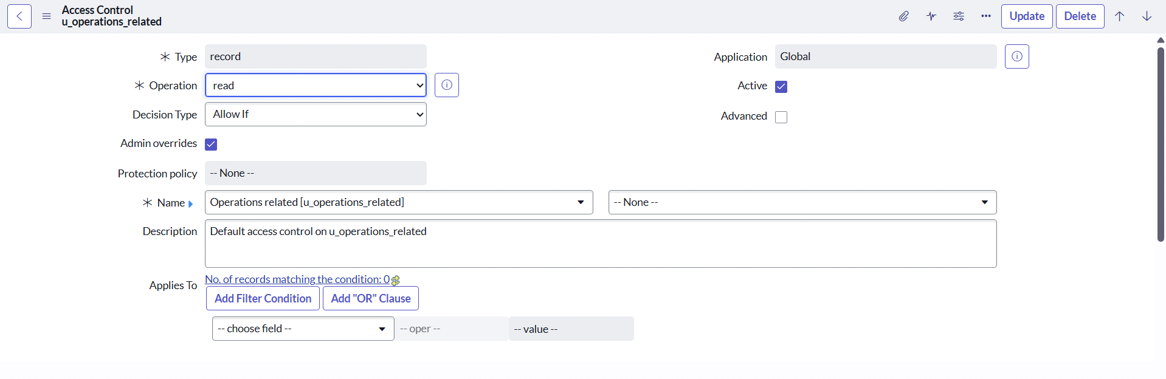

* Scroll down under requires role
* Double click on insert a new row
* Give admin role
* Click on submit
* Similarly create 4 acl for the following fields

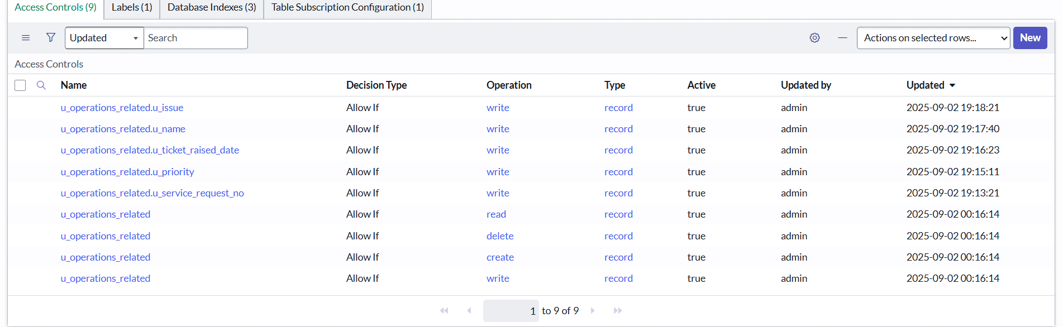

Milestone 8: Flow

Activity 1: Create a Flow to Assign operations ticket to group

* Open service now.
* Click on All  >> search for Flow Designer
* Click on Flow Designer under Process Automation.
* After opening Flow Designer Click on new and select Flow.
* Under Flow properties Give Flow Name as “ Regarding Certificate”.
* Application should be Global.
* Select Run user as “ System user ” from that choice.
* Click on Submit.
* Create flow name “Regarding certificate”

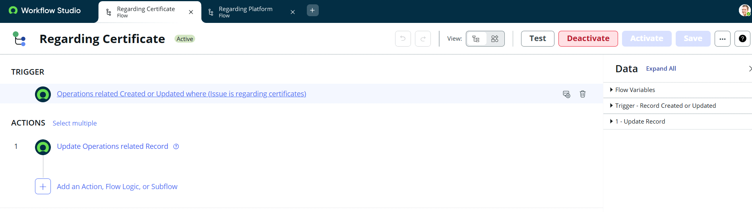

* Click on Add a trigger
* Select the trigger in that Search for “create or update a record”  and select that.
* Give the table name as “ Operations related ”.

1.Give the Condition as  
Field : issue

Operator : is

Value : Regrading Certificates

1. After that click on Done.

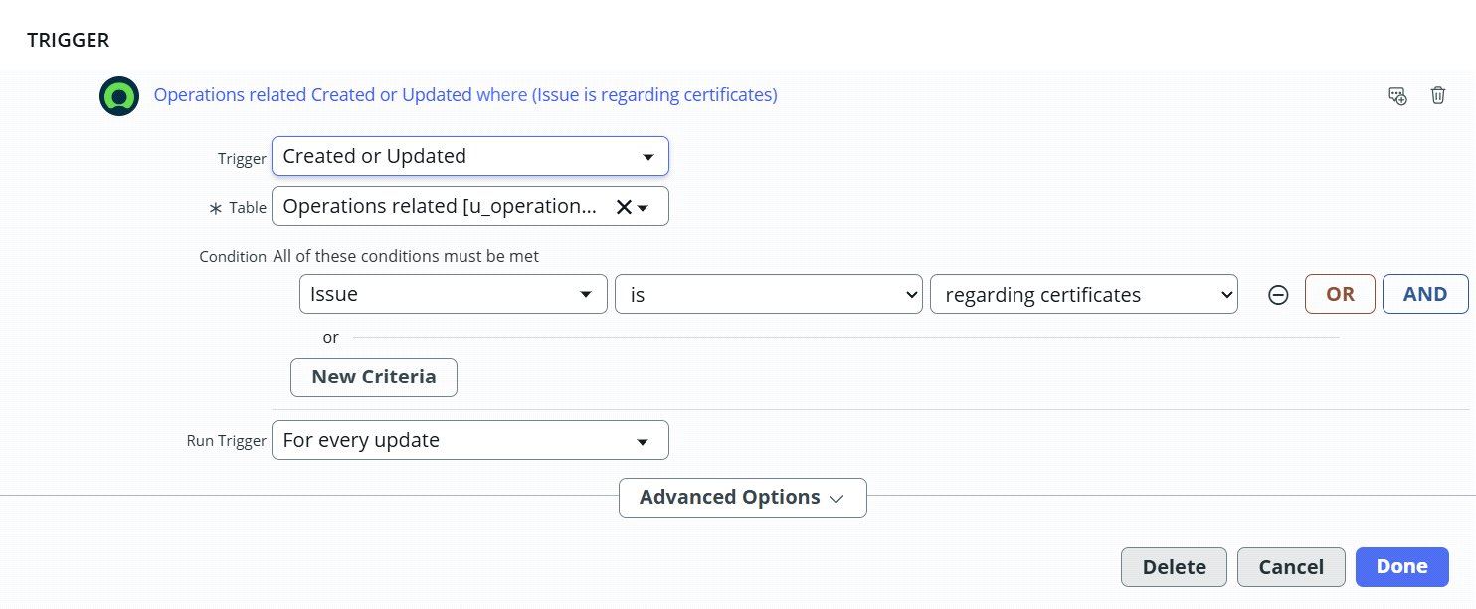

1. Now under Actions.
2. Click on Add an action.
3. Select action in that search for “ Update Record ”.
4. In Record field drag the fields from the data navigation from left side
5. Table will be auto assigned after that
6. Give the field as “ Assigned to group ”
7. Give value as “ Certificates ”
8. Click on Done.
9. Click on Save to save the Flow.
10. Click on Activate.

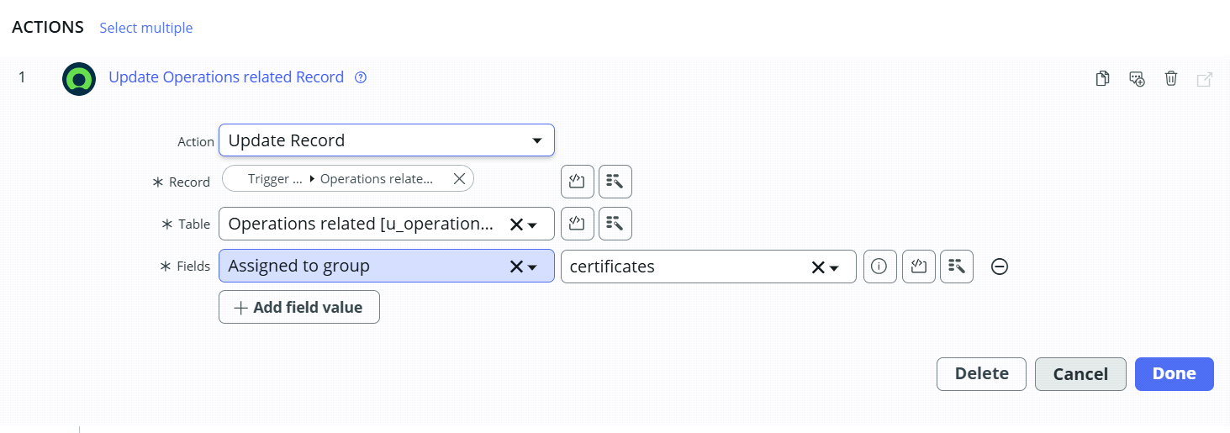



Activity 2: Create a Flow to Assign operations ticket to Platform group

* Open service now.
* Click on All  >> search for Flow Designer
* Click on Flow Designer under Process Automation.
* After opening Flow Designer Click on new and select Flow.
* Under Flow properties Give Flow Name as “ Regarding Platform ”.
* Application should be Global.
* Select Run user as “ System user ” from that choice.
* Click on Submit.

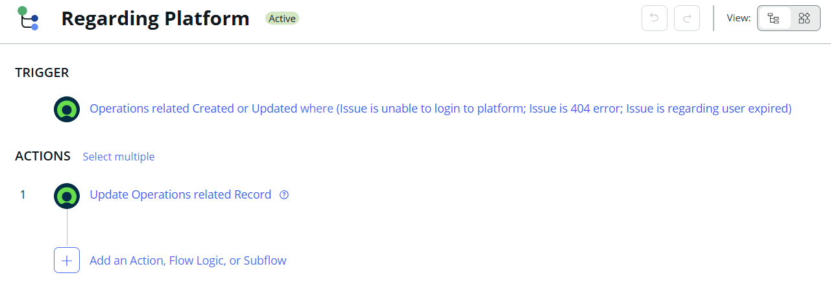

* Click on Add a trigger
* Select the trigger in that Search for “create or update a record”  and select that.
* Give the table name as “ Operations related ”.
* Give the Condition as

Field : issue

Operator : is

Value : Unable to login to platform

* Click on New Criteria

Field : issue

Operator : is

Value : 404 Error

* Click on New Criteria

Field : issue

Operator : is

Value : Regrading User expired

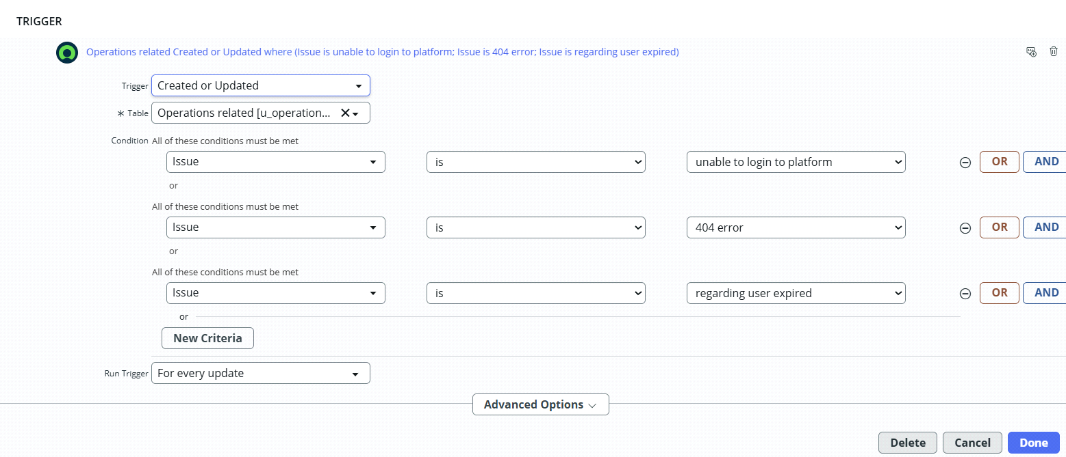

1. After that click on Done.
2. Now under Actions.
3. Click on Add an action.
4. Select action in that search for “ Update Record ”.
5. In Record field drag the fields from the data navigation from left side
6. Table will be auto assigned after that
7. Give the field as “ Assigned to group ”.
8. Give value as “ Platform ”.
9. Click on Done.
10. Click on Save to save the Flow.
11. Click on Activate.

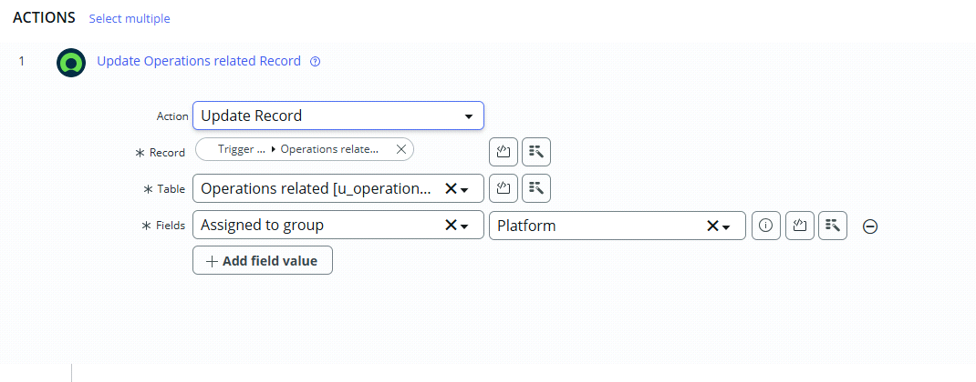

Conclusion:

The implementation of the automated ticket routing system at ABC Corporation has been a significant success. By leveraging the capabilities of ServiceNow, we have streamlined the process of assigning support tickets to the appropriate teams, addressing the challenges of manual routing, and ensuring timely resolution of issues.